Best Answers

Group A

1. What are the fates of base substitution mutation?

Although a base substitution alters only a single codon in a gene, it can still have a significant impact on protein production. In fact, depending on the nature of the codon change, base substitutions can lead to three different subcategories of mutations. The first of these subcategories consists of missense mutations, in which the altered codon leads to insertion of an incorrect amino acid into a protein molecule during translation; the second consists of nonsense mutations, in which the altered codon prematurely terminates synthesis of a protein molecule; and the third consists of silent mutations, in which the altered codon codes for the same amino acid as the unaltered codon.

1. Describe the effects of intron phase on alternative splicing with diagram.

Introns can be divided into three types based on phases: phase 0, phase 1, and phase 2. A phase 0 intron does not disrupt a codon, a phase 1 intron disrupts a codon between the first and second bases, whereas a phase 2 intron disrupts a codon between the second and third bases.

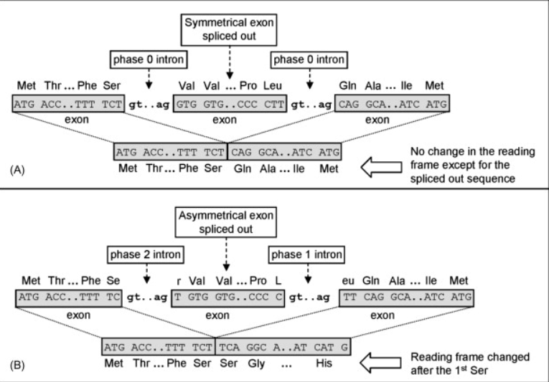

1. How can you identify the start codon in the mRNA sequence? (refer to the last week's lecture)

Translation initiation code is AUG (in DNA it is ATG) as methionine is always the first amino acid. Sometimes, there are multiple start codon in the sequence. Therefore, to find out the original one we need to find some characteristics. The Kozak Sequence can explain these characteristics.

* The codon just before the start codon always starts with a purine based nucleotide (A or G).
* The immediate base after the start codon is always G.

5’ACC RUA AUG GCU3’

In this example R denotes a purine base (A or G) and G is the prevalent base after the Start codon.

1. Describe the consequences of frame shift mutation.

Frameshift mutations arise when the normal sequence of codons is disrupted by the insertion or deletion of one or more nucleotides, provided that the number of nucleotides added or removed is not a multiple of three. Therefore, the open reading frame (ORF) is completely changed and results in abnormal protein products with an incorrect amino acid sequence that can be either longer or shorter than the normal protein.

1. What type of mutation is sickle cell anemia? Explain the molecular basis of sickle cell anemia.

Sickle cell anemia is the result of a point mutation in the hemoglobin gene. As a result valine is found instead of glutamine. This causes red blood cells to form a sickle shape. People who inherit one sickle cell gene and one normal gene have sickle cell trait.

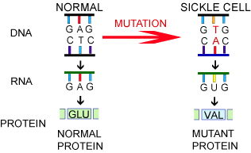

1. What is open reading frame? How frame shift mutation can be happened? Explain with example.

In molecular genetics, an open reading frame (ORF) is the part of a reading frame that has the ability to be translated. An ORF is a continuous stretch of codons that begins with a start codon (usually AUG) and ends at a stop codon (usually UAA, UAG or UGA).

Frameshift mutation occurs when the addition or loss of DNA bases changes a gene's reading frame. A reading frame consists of groups of 3 bases that each code for one amino acid. A frameshift mutation shifts the grouping of these bases and changes the code for amino acids.

Diseases caused by frameshift mutations in genes include Crohn's disease, cystic fibrosis, and some forms of cancer.

1. Two major types of mutations are gene mutation and chromosome mutation. Which mutation is more lethal and why?

The mutations that have the most severe effect are the chromosomal mutations because they cover a greater amount of the genome, not just one or two nucleotides.

Regarding to the single base substitution mutations, the most dangerous will be those that completely eliminate the activity of a certain gene or protein, although all this depend on which part of the sequence is affected, since it is not the same if it affects a promoter, a exon or an intron, for example.

1. If you want to multiply the number of a target gene, what process you will do? Explain the process in detail.

To multiply a target gene polymerase chain reaction (PCR) is carried out using suitable primers. PCR involves multiple cycles consisting 3 steps- 1. Denaturation of double stranded DNA, 2. Annealing of primers, and 3. Elongation (addition of nucleotides along the template strand using DNA polymerase). The number of cycles are dependent on how much the target concentration of the particular sequence is required. Following is the details.

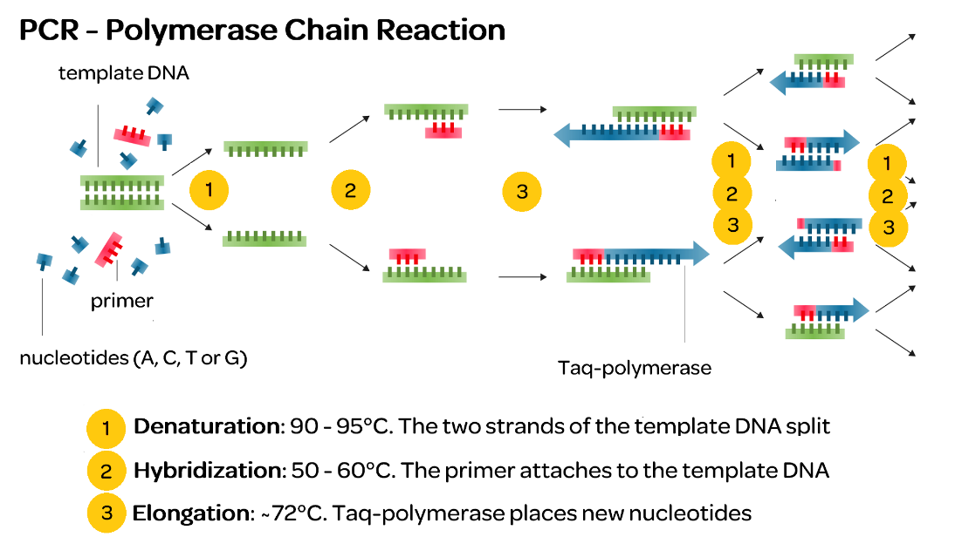

1. Write the functions of UTR of mRNA.

The 5′ untranslated region (5′ UTR) (also known as a leader sequence or leader RNA) is the region of an mRNA that is directly upstream from the initiation codon. This region is important for the regulation of translation of a transcript by differing mechanisms in viruses, prokaryotes and eukaryotes.

The 3′-untranslated region plays a crucial role in gene expression by influencing the localization, stability, export, and translation efficiency of an mRNA. It contains various sequences that are involved in gene expression, including microRNA response elements (MREs), AU-rich elements (AREs), and the poly(A) tail.

Group B

1. **Why Phosphate bond is important in DNA or RNA structure?**

* 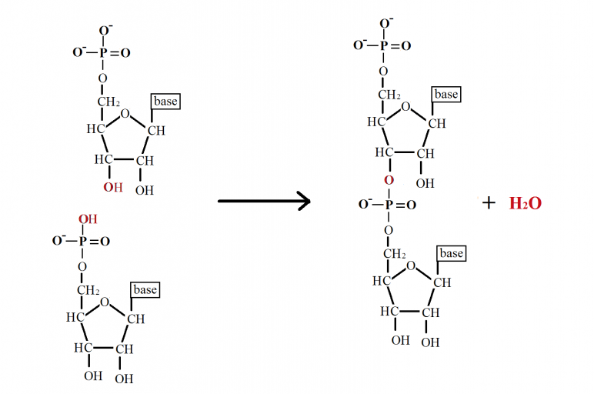Structural framework of nucleic acid
* The energy for producing the DNA polymer comes from the phosphate itself
* When DNA is synthesized there is an ATP an energy molecule that part of the phosphate backbone i.e., used to link the DNA together
* Very stable bond so the integrity of the genetic code is well conserved in the DNA or RNA.

1. **Why G-C forms three hydrogen bonds while A-T forms only two?**

Because when the guanine and cytosine join together, one hydrogen bond is formed between the oxygen atom from the C2 of the cytosine and one hydrogen atom of the amino group located in the C2 of the guanine. The second hydrogen bond is found between N3 of the cytosine and the hydrogen atom that is attached to N1 of the guanine. The last one is found between the hydrogen atom of the amino group in the C4 of the cytosine and the oxygen in the C6 if the guanine.

On the other hand, when an adenine and a thymine join, one hydrogen bond is found between one of the hydrogen atoms located in the amino group in the C6 of the adenine and the oxygen atom if the C4 of the thymine. The second one is formed between the nitrogen atom in the position number 1 of the adenine molecule and the hydrogen atom linked to N3 of the thymine.

To sum up, the difference between these 2 types of unions is due to the structure of the bases.

1. **Briefly explain the importance of poly A tail of mRNA.**

The poly A tail is added to RNA at the end of the transcription. Regarding the function of this tail, there is no consensus among scientists around the world, although it is believed that it may be involved in the transport of the mRNA from the nucleus to the cytoplasm, protect the mRNA molecule from enzymatic degradation, as well as in the correct translation process of the mRNA into proteins. Furthermore, there are some evidences that show that it is involved in the correct cleavage if the last intron during the splicing process.

1. **What is nonsense mutation? Describe with an example.**

This kind of mutation consists of a substitution of a single base pair that results in a premature stop codon. This may lead to a peptide that is much shorter than it should be. As a result, the protein may lose its biological function.

For example:

Original sequence: 5’AUG AGC GAU UCA CCU3’

Mutated sequence: 5’AUG AGC GAU U**A**A CCU3’

In this example, the 4th codon was UCA which encodes the amino acid Serine. After substitution mutation (C is substituted by A) the codon becomes UAA which is a stop codon. Therefore, the translation will stop after the 3rd codon and a shorter peptide chain will be formed.

1. **Write the importance of polypeptide bond.**

This type of bonds is so important because they form the backbone of proteins by joining two amino acids molecules. This will lead into the formation of a peptide. This is a real important thing in living organisms, as proteins are involved in many different processes of the cell metabolism.

1. **Is this possible to create a DNA sequence from an RNA and how?**

Yes, it is possible.

This process is called reverse transcription or retrotranscription and it consists of the synthesis of a cDNA molecule from an RNA molecule. This process is made by the enzyme reverse transcriptase, and it is found in the nature in some viruses, like the famous HIV.

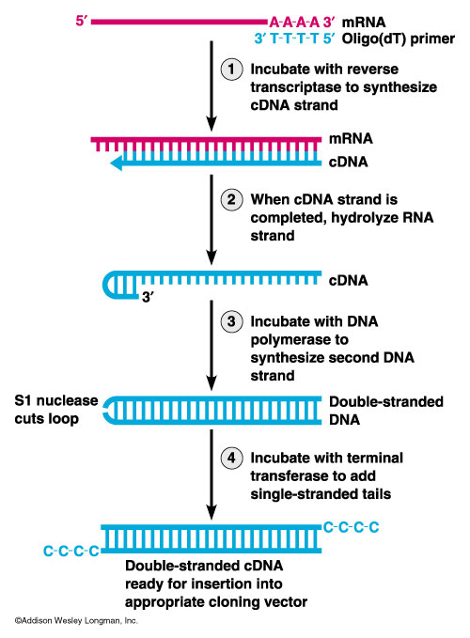

1. **Which gene mutation is much severe and why? (The following answer is much suitable for a question like “which mutation is much severe and why?”)**

The mutations that have the most severe effect are the chromosomal mutations because they cover a greater amount of the genome, not just one or two nucleotides.

Regarding to the single base substitution mutations, the most dangerous will be those that completely eliminate the activity of a certain gene or protein, although all this depend on which part of the sequence is affected, since it is not the same if it affects a promoter, a exon or an intron, for example.

**Best answer is:**

**Frameshift mutation** is severe because the open reading frame (ORF) is changed and it will result in abnormal protein products with an incorrect amino acid sequence. It can cause the complete loss of function of the protein or in adverse cases the signalling pathway can be largely affected.

1. **What are the possible outcome of Chromosome mutation?**

There are 4 different types or outcomes for the chromosomal mutations:

The first one, is the deletion of a part of the chromosome, that means that a chromosome segment is lost. The second one is the translocation, in which a segment of a chromosome moves to another chromosome. The third one is the duplication, by which a part of the chromosome is duplicated and transferred to the homologous. And the last one, is the inversion, that consists in the inversion of a segment of the chromosome.

The results of all these mutations in humans depends on the type. Deletions usually are lethal if the loss of genetic material is significant. If the mutation is related to a change in the position, many genes are involved, and it is also lethal. But we cannot forget that the outcome is going to depend on the place where the mutation is located and the genes that are affected.

1. **Define the domain and motif of protein. Why they are required?**

The domain of a protein is a part or region of the peptide molecules that is conserved, and it can evolve, function and exist in an independent way from the rest of the protein chain.

The motif of a protein is a small region or part of the protein that is shared among different proteins. These proteins have a recognizable region on their structure, and they are all related to a similar biological function.

The domain and the motif of a protein is important because these regions are usually responsible for a particular function or interaction, contributing to the overall role of the whole protein